

JOB MARKET ANALYSIS

Final Project Report – PRDA-04

Submitted By
Name: SUHANI GUPTA
Course: Certified Data Analyst
Project Title: PRDA-04_JOB MARKET ANALYSIS
Team ID: PTID-CDA-APR-26-11397
Submission Date: 5th May, 2026

TABLE OF CONTENTS
- Introduction
- Project Objective
- Problem Statement
- Dataset Description
- Tools and Technologies Used
- Why These Tools Were Used
- Methodology
- Data Extraction Process
- Data Cleaning and Preprocessing
- Exploratory Data Analysis
- State-wise Job Analysis
- Salary Analysis by State
- Industry and Company Analysis
- Job Title Analysis
- Skills Analysis
- Education vs Salary Analysis
- Additional Insights
- Dashboard Overview
- Suggestions and Recommendations
- Challenges Faced
- Conclusion
- References

1. INTRODUCTION
The demand for data science professionals has increased significantly in recent years. Organizations across industries are using data-driven strategies to improve decision-making, optimize operations, and gain competitive advantages. This has resulted in rapid growth in job opportunities related to Data Science, Machine Learning, Data Analytics, Artificial Intelligence, and Business Intelligence.
The purpose of this project is to analyze the job market trends for data science-related roles using a real-world dataset. The project focuses on identifying the most active hiring states, industries, companies, required skills, salary trends, and educational requirements.
The analysis helps understand how the job market is evolving and what technical skills and qualifications are most valuable for job seekers and employers.

2. PROJECT OBJECTIVE
The main objectives of this project are:
- To analyze job market trends for data science-related roles
- To identify states with the highest number of job openings
- To analyze salary distribution across different states
- To identify top industries hiring data science professionals
- To identify companies with maximum job openings
- To analyze the most common job titles
- To study skills required for different job roles
- To examine the relationship between education and salary
- To generate insights useful for employers and job seekers

3. PROBLEM STATEMENT
Organizations are rapidly hiring data science professionals, but understanding market trends, required skills, and salary structures remains challenging. Job seekers often struggle to identify which skills and qualifications are most valuable in the industry.
This project aims to solve the problem by analyzing job market data and generating meaningful insights regarding:
- Hiring patterns
- Salary trends
- Skills demand
- Educational influence
- Industry-wise opportunities
- State-wise job distribution
The findings can support both recruiters and job seekers in making informed decisions.

4. DATASET DESCRIPTION
The dataset used in this project contains job-related information for data science roles.
Dataset Information
- Total Records: 742 Rows
- Total Features: 42 Columns
- Source: MySQL Database
Important Columns in Dataset
- Job Title
- Salary Estimate
- Company Name
- Industry
- Sector
- Location
- Rating
- Revenue
- Skills
- Education
- Seniority
- Minimum Salary
- Maximum Salary
- Average Salary
Purpose of Dataset
The dataset was used to:
- Study hiring patterns
- Understand salary distribution
- Analyze demand for technical skills
- Identify active hiring companies and industries
- Examine relationships between salary and education

5. TOOLS AND TECHNOLOGIES USED
Programming and Analysis Tools
- Python
- Jupyter Notebook (Anaconda)
- MySQL Database
- Power BI
Python Libraries Used
- Pandas
- NumPy
- Matplotlib
- Seaborn
- SQLAlchemy
- PyMySQL
- OpenPyXL

6. WHY THESE TOOLS WERE USED
Python
Python was used because it is one of the most powerful programming languages for data analysis and machine learning.
Pandas
Used for data cleaning, preprocessing, manipulation, and analysis.
NumPy
Used for numerical operations and handling arrays.
Matplotlib and Seaborn
Used for creating charts and visualizations.
MySQL
Used for database storage and data extraction.
Power BI
Used for building interactive dashboards and business intelligence visualizations.
Jupyter Notebook
Used for writing and executing Python code step-by-step.

7. METHODOLOGY
The project followed a structured data analysis process:
- Data Extraction from MySQL database
- Data Cleaning and Preprocessing
- Exploratory Data Analysis (EDA)
- Visualization Creation
- Dashboard Development
- Insight Generation
- Report Preparation

8. DATA EXTRACTION PROCESS
The dataset was extracted from a MySQL database using Python.
Database Connection Process
- Imported required libraries
- Connected to MySQL database using credentials
- Queried the Market table
- Loaded data into Pandas DataFrame
- Saved raw dataset for backup and future use
Example Steps Performed
- Connection established using PyMySQL
- SQL query executed using Pandas
- Data loaded into Python environment

9. DATA CLEANING AND PREPROCESSING
Data cleaning is one of the most important steps in data analysis because raw datasets often contain missing values, duplicate records, inconsistent formatting, and incorrect information.
Cleaning Steps Performed
1. Handling Missing Values
- Replaced invalid values such as -1 with null values
- Filled missing numeric values using median
- Filled missing categorical values using mode
2. Standardizing Column Names
- Renamed columns for better readability
- Removed spaces and unnecessary symbols
3. Cleaning Company Names
- Removed unwanted text and ratings from company names
- Standardized naming format
4. Extracting State Information
- Extracted state names from location column
- Created separate state column for analysis
5. Removing Duplicates
- Checked and removed duplicate rows
6. Data Type Conversion
- Converted columns into appropriate numeric and categorical formats
Final Output
- Cleaned dataset prepared successfully
- Data ready for analysis and visualization

10. EXPLORATORY DATA ANALYSIS (EDA)
Exploratory Data Analysis was performed to understand the dataset and identify important trends.
EDA helps in:
- Understanding distribution of variables
- Identifying trends and patterns
- Detecting outliers
- Understanding relationships between features
The following analyses were performed:
- State-wise job analysis
- Salary analysis
- Industry analysis
- Company analysis
- Job title analysis
- Skills analysis
- Education vs salary analysis

11. STATE-WISE JOB ANALYSIS
Analysis Performed
The number of job postings was counted state-wise to identify regions with the highest demand for data science professionals.
Insights
- A few states dominate the job market significantly.
- Technology and business hubs have the highest number of job openings.
- States with strong IT ecosystems offer more opportunities.
- Job seekers targeting these states may have better career opportunities.
Importance of Analysis
This analysis helps:
- Job seekers identify active hiring regions
- Companies understand regional hiring competition
- Organizations plan recruitment strategies
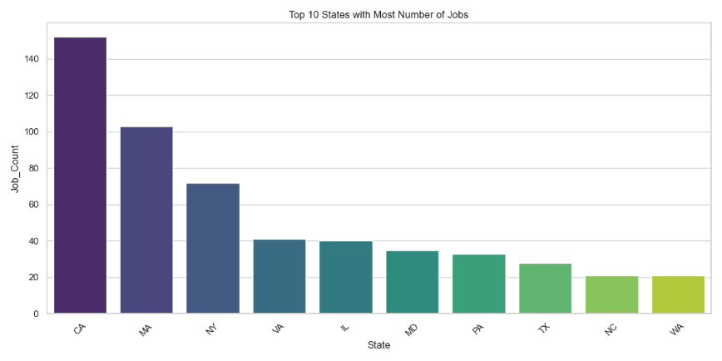

12. SALARY ANALYSIS BY STATE
Analysis Performed
The following salary metrics were analyzed state-wise:
- Average Minimum Salary
- Average Maximum Salary
- Average Overall Salary
Insights
- Salary ranges differ significantly across states.
- States with higher living costs generally offer higher salaries.
- Demand for skilled professionals impacts salary levels.
- Companies in technology hubs provide better compensation.
Business Importance
Salary benchmarking helps:
- Employers offer competitive packages
- Employees understand market standards
- Companies retain skilled professionals

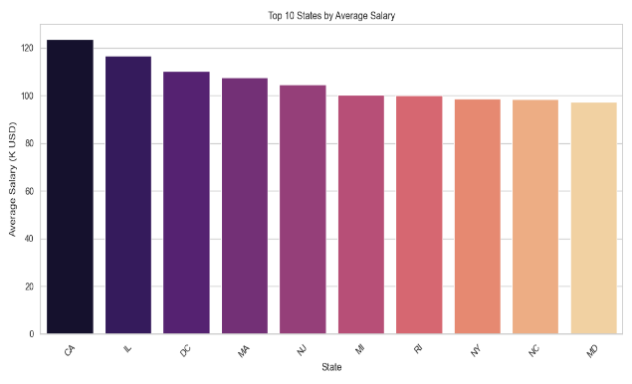
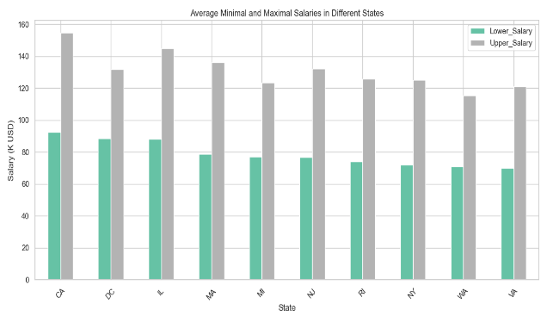

13. INDUSTRY AND COMPANY ANALYSIS
Industry Analysis
The project identified industries with the highest demand for data science professionals.
Insights
- Data science demand is concentrated in specific industries.
- Technology, consulting, healthcare, finance, and analytics industries show strong hiring activity.
- Industries are increasingly investing in AI and analytics solutions.
Company Analysis
Companies with the maximum number of job openings were identified.
Insights
- A small number of companies are hiring aggressively.
- Large organizations dominate recruitment.
- Companies are building strong analytics teams.
Importance
This analysis helps:
- Job seekers identify active employers
- Companies understand market competition
- Recruiters benchmark hiring strategies

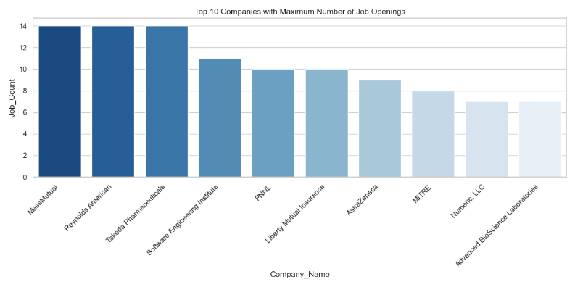

14. JOB TITLE ANALYSIS
Analysis Performed
The most common job titles and average salaries by job title were analyzed.
Common Roles Identified
- Data Scientist
- Data Analyst
- Machine Learning Engineer
- Business Analyst
- Data Engineer
Insights
- Data Scientist and Data Analyst roles are highly demanded.
- Specialized and senior roles offer higher salaries.
- Job title directly influences salary structure.
- Technical expertise increases earning potential.
Importance
This analysis helps students and professionals understand:
- Which roles are most demanded
- Which job profiles offer higher salaries
- Which career paths are growing rapidly

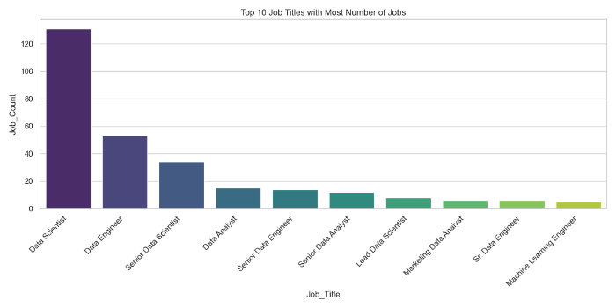

15. SKILLS ANALYSIS
Analysis Performed
Skills required by companies were analyzed across different job roles.
Most Demanded Skills
- Python
- SQL
- Excel
- AWS
- Spark
- Tableau
- Hadoop
- Machine Learning
- Power BI
Insights
- Python and SQL are core skills for most roles.
- Cloud and big-data technologies are highly valued.
- Visualization tools improve employability.
- Companies prefer candidates with practical technical skills.
Importance
This analysis helps:
- Students identify important skills
- Professionals plan upskilling strategies
- Companies understand current market demand
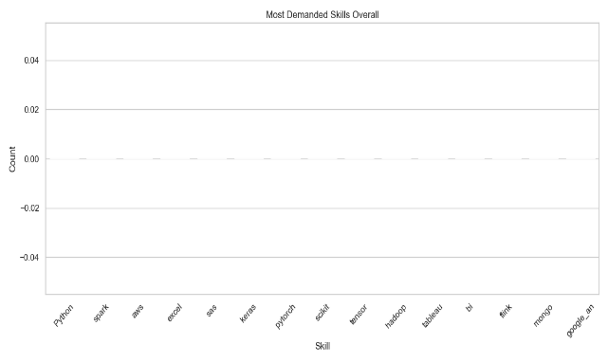
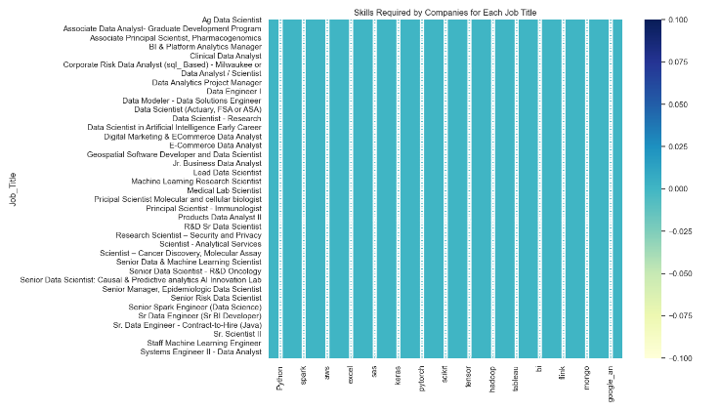

16. EDUCATION VS SALARY ANALYSIS
Analysis Performed
The relationship between educational qualifications and salary was studied.
Insights
- Higher education may positively impact salary.
- However, technical skills and practical experience remain highly important.
- Employers focus on skill-based hiring.
- Certifications and project experience improve opportunities.
Importance
This analysis helps students understand:
- The value of education
- The importance of technical skills
- The need for practical experience

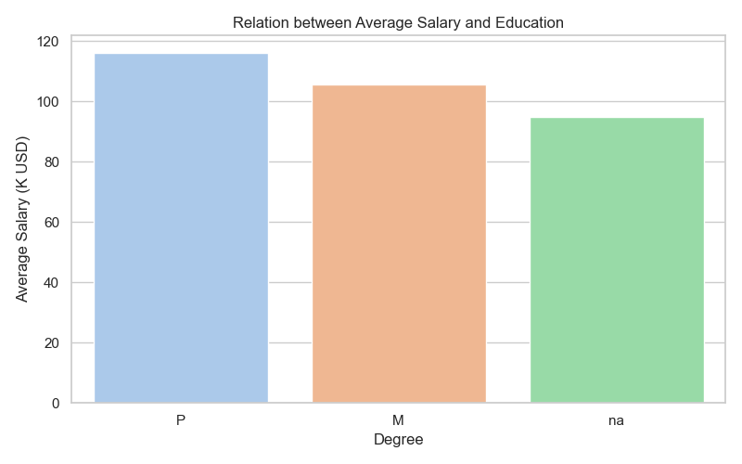

17. ADDITIONAL INSIGHTS
Additional findings observed during analysis:
- Senior roles receive higher average salaries.
- Industry-wise salary differences are visible.
- Some sectors offer more opportunities than others.
- Numerical correlations show relationships among salary-related features.
- Practical technical skills are highly valued by employers.
- Demand for AI and machine learning skills is increasing rapidly.

18. DASHBOARD OVERVIEW
An interactive Power BI dashboard was created to visualize insights effectively.
Dashboard Features
- State-wise job distribution
- Salary trends
- Industry demand
- Company hiring activity
- Skills analysis
- Job title distribution
Benefits of Dashboard
- Interactive analysis
- Easy understanding of trends
- Better business decision-making
- Improved data visualization
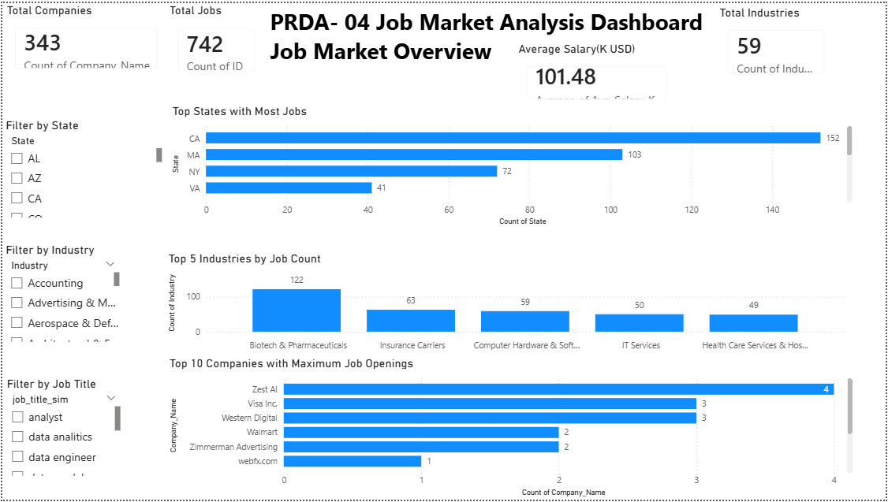
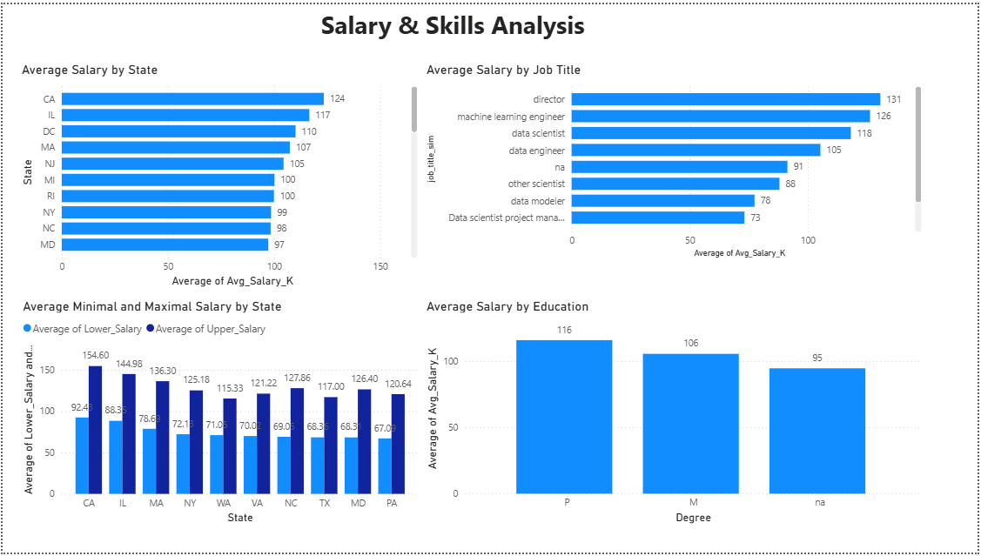

19. SUGGESTIONS AND RECOMMENDATIONS
Based on the analysis, the following recommendations are suggested:
For Companies
- Focus hiring in high-demand states
- Benchmark salaries according to market trends
- Improve job descriptions with clear skill requirements
- Invest in employee upskilling programs
- Use skill-based recruitment methods
For Job Seekers
- Learn Python and SQL as core skills
- Build practical projects and portfolios
- Gain experience in cloud and visualization tools
- Improve analytical and problem-solving skills
- Stay updated with industry trends

20. CHALLENGES FACED
During the project, several challenges were encountered:
- Missing and inconsistent data
- Data cleaning complexity
- Handling null values
- Standardizing location and salary formats
- Understanding complex relationships between variables
- Creating meaningful visualizations
These challenges were solved using proper preprocessing and analytical techniques.

21. CONCLUSION
The project successfully analyzed the data science job market using database-driven analysis techniques.
Major Findings
- Certain states dominate data science hiring.
- Salary trends vary significantly across locations.
- Python, SQL, and cloud technologies are highly demanded.
- Data Scientist and Data Analyst roles remain the most popular.
- Skill-based hiring is becoming more important than traditional qualifications alone.
Overall Impact
The analysis provides valuable insights for:
- Employers
- Recruiters
- Students
- Job seekers
- Organizations
The project demonstrates how data analytics can help understand market trends and support better business and career decisions.
Final Statement
This project provides a clear understanding of the evolving data science job market and highlights the importance of technical skills, analytical ability, and practical experience in building a successful career in data analytics and data science.

22. REFERENCES
- Python Official Documentation – https://www.python.org/doc/
- Pandas Documentation – https://pandas.pydata.org/docs/
- NumPy Documentation – https://numpy.org/doc/
- Matplotlib Documentation – https://matplotlib.org/stable/contents.html
- Seaborn Documentation – https://seaborn.pydata.org/
- MySQL Documentation – https://dev.mysql.com/doc/
- Jupyter Notebook Documentation – https://jupyter.org/documentation
- Power BI Documentation – https://learn.microsoft.com/power-bi/
- OpenAI ChatGPT – https://chat.openai.com/

